OpenRice Booking Webhook API
HungryHub to Openrice

Technical Document

Version 1.1

Document Version Summary

Version | Status | Date | Author/Editor
1.0 | Created | 2023-05-29 | Steven Tsoi
1.1 | Modified | 2023-05-30 | Diamond Dai

1. API Detail (From HungryHub to OpenRice)

In order to synchronize the latest status of booking for both restaurant and customer, for some statuses, HungryHub should notice OpenRice booking status change through webhook API. Upon receiving the webhook request, OpenRice will retrieve latest information of the booking and notify the customer for the update. It is essential for customer experience and booking case handing.
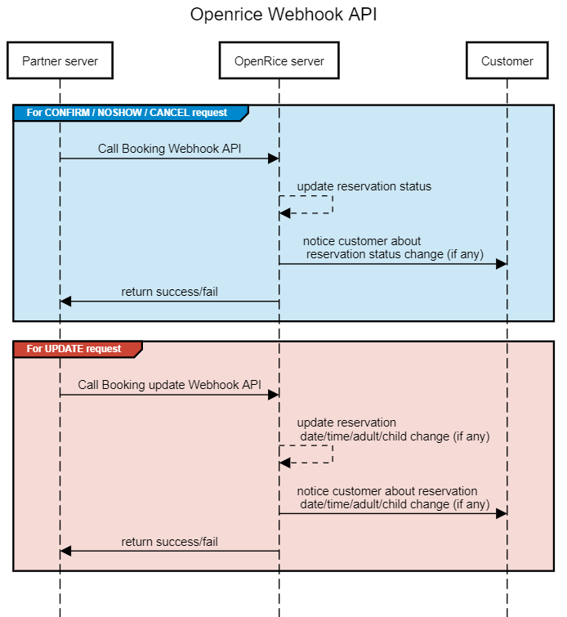
** Important remark: For success process of webhook request, OpenRice API should return HTTP status code 200 with content of “success = true”. In case partner (HungryHub) receive HTTP status code other than 200 or “success = false”, we suggest partner (HungryHub) should implement a retry mechanism, with retry limit = 2 times for each webhook request.

1.1 General Protocol
API URL Path  (TBC) | https://api.openrice.com/biz/api/v1/booking/hungryhub/webhook
Testing platform ARI URL Path | https://staging-api.openrice.com/biz/api/v1/booking/hungryhub/webhook
HTTP Action | POST
Request Example | POST https://api.openrice.com/biz/api/v1/booking/hungryhub/webhook
X-HungryHub-Client-Id | Bearer D4GsE8S8nXcS2hPH3Br3o2IrjmPcfyjcCqBRhh6x6jh8umn3G1iV4H1noor3CjLILufzHa4zksX5Aykx
Request Content-Type | application/json; charset=utf-8
Header | X-HungryHub-Client-Id: Bearer D4GsE8S8nXcS2hPH3Br3o2IrjmPcfyjcCqBRhh6x6jh8umn3G1iV4H1noor3CjLILufzHa4zksX5Aykx
Sample Request Content | {  “partnerBookingId”: “2667759”,  “vendorReservationId”: “9”  “status”: “CONFIRM”  }
Sample Request Content (for UPDATE) | {  “partnerBookingId”: “2667759”,  “vendorReservationId”: “9”  “status”: “UPDATE”,  “date”: “2023-05-31”  “time”: “18:00”,  “adult”: 2,  “child”: 0  }
Sample Success Response | {  “success”: true  }
Sample Fail Response | {  “success”: false  }

1.2 Request Parameter Detail
Parameter | Type | Required | Remark
partnerBookingId | string | Y | HungryHub booking Id (equal to the field of return of HungryHub Get Restaurant Details API > data > attribute > id)  FYR - Captured Image of HungryHub Get Restaurant Details API response:  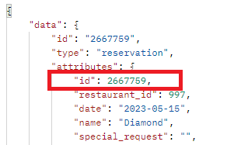
vendorReservationId | string | Y | HungryHub vendor reservation Id (equal to the field of return of HungryHub Get Restaurant Details API > data > attribute > vendor_reservation_id)  FYR - Captured Image of HungryHub Get Restaurant Details API response:  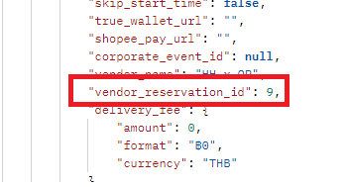
status | string | Y | Accept value:  UPDATE  - Booking information was updated by restaurant, support booking date/booking time/ seat update  CONFIRM  - Given that Customer attendance was confirmed by restaurant  NOSHOW  - Given that customer did not attend reservation, booking was marked as no-show by restaurant  CANCEL  - Booking was cancelled by restaurant

1.3 Request Examples
UPDATE Request Sample | POST https://staging-api.openrice.com/biz/api/v1/booking/hungryhub/webhook  X-HungryHub-Client-Id: Bearer D4GsE8S8nXcS2hPH3Br3o2IrjmPcfyjcCqBRhh6x6jh8umn3G1iV4H1noor3CjLILufzHa4zksX5Aykx  Body:  {  "status":"UPDATE"  "partnerBookingId": "2667759"  " vendorReservationId”: “9”  "date": "2023-05-31",  "time": "18:00",  "adult": 2,  "child": 0  }
CONFIRM Request Sample | POST https://staging-api.openrice.com/biz/api/v1/booking/hungryhub/webhook  X-HungryHub-Client-Id: Bearer D4GsE8S8nXcS2hPH3Br3o2IrjmPcfyjcCqBRhh6x6jh8umn3G1iV4H1noor3CjLILufzHa4zksX5Aykx  Body:  {  "status":"CONFIRM"  "partnerBookingId": "2667759"  " vendorReservationId”: “9”  }
NOSHOW Request Sample | POST https://staging-api.openrice.com/biz/api/v1/booking/hungryhub/webhook  X-HungryHub-Client-Id: Bearer D4GsE8S8nXcS2hPH3Br3o2IrjmPcfyjcCqBRhh6x6jh8umn3G1iV4H1noor3CjLILufzHa4zksX5Aykx  Body:  {  "status":"NOSHOW"  "partnerBookingId": "2667759"  " vendorReservationId”: “9”  }
CANCEL Request Sample | POST https://staging-api.openrice.com/biz/api/v1/booking/hungryhub/webhook  X-HungryHub-Client-Id: Bearer D4GsE8S8nXcS2hPH3Br3o2IrjmPcfyjcCqBRhh6x6jh8umn3G1iV4H1noor3CjLILufzHa4zksX5Aykx  Body:  {  "status":"CANCEL"  "partnerBookingId": "2667759"  " vendorReservationId”: “9”  }

1.4 HungryHub reservation status matching (suggestion)

Since there are a lot of HungryHub reservation statuses, here below as our suggestion to HungryHub to call Openrice webhook.
HungryHub reservation status | Detail | Webhook suggestion
waiting_for_payment | this may not use for booking from OR | No action
no_show | Given that customer does not attend reservation, restaurant can mark reservation status to no_show | Call Openrice webhook with status “NOSHOW”
arrived | if customer does attend reservation, restaurant will change reservation status to arrived | Call Openrice webhook with status “CONFIRM”
cancelled | if restaurant cancel reservation from reservation change to cancelled | Call Openrice webhook with status “CANCEL”
rejected | if restaurant reject reservation from reservation change to rejected | Call Openrice webhook with status “CANCEL”
cancel_modified | This is status of old reservation if customer cancel the old reservation but create new reservation with same datetime and restaurant | Suppose old reservation changed to cancel in OR side, no action
refund | Refund process will be done in OR side, so this status might not applicable to booking from OR side | No action
pending_confirmation | customer edit reservation and waiting for restaurant confirmation | No action
order_being_prepared | customer has arrived in restaurant and the order is being prepared by restaurant | No action
pending_arrival  (no date/time/seat change) | create reservation successfully and reservation is active, waiting customer attend | No action
pending_arrival  (restaurant change date/time/seat) | Restaurant update reservation date/time/seat, Hungryhub should notice Openrice, in turn customer side | Call Openrice webhook with status “UPDATE” with updated detail in content

1.5 Cases Handling

1.5.1 Normal Update Request
Openrice booking status | Webhook call by HungryHub | Description | Expect Result
PENDING | UPDATE | HungryHub side intends to update booking date/time/capacity which Openrice booking status is pending | Return Http 200 & success = true, booking detail will be updated in Openrice side

1.5.2 Normal NoShow / Confirm / Cancel Request
Openrice booking status | Webhook call by HungryHub | Description | Expect Result
PENDING | NOSHOW / COFIRM / CANCEL | HungryHub side intends to update booking status which Openrice booking status is pending | Return Http 200 & success = true, booking status is updated in Openrice side
** Openrice rule which to be confirmed: If booking time passed 48 hours but Openrice system did not receive any CONFIRM/NOSHOW webhook request from HungryHub merchant side, the booking status will automatically become “CONFIRM”. Booking status will not be further updated even call NOSHOW webhook request.

1.5.3 Duplicate NoShow / Confirm / Cancel Request
Openrice booking status | Webhook call by HungryHub | Description | Expect Result
NOSHOW / CONFIRM / CANCEL | NOSHOW / CONFIRM / CANCEL | HungryHub side intends to update booking status which Openrice booking status has already been NoShow / Confirm / Cancel | Return Http 200 & success = true,  But nothing will be updated in Openrice side

1.5.4 Update booking with status of NoShow / Confirm / Cancel Request
Openrice booking status | Webhook call by HungryHub | Description | Expect Result
NOSHOW / CONFIRM / CANCEL | UPDATE | HungryHub side intends to update booking detail which Openrice booking status has already been NoShow / Confirm / Cancel | Return Http 200 & success = true,  But nothing will be updated in Openrice side

1.5.5 Exceptional cases
Openrice booking status | Webhook call by HungryHub | Description | Expect Result
Any status | Any status | HungryHub side intends to update booking in Openrice side but something not working in the process | Return Http 200 & success = false, nothing will be updated in Openrice side
** Important remark: For this case, partner (HungryHub) should implement a retry mechanism for failed request. Suggested retry limit for each webhook request is 2.

2. Remark

Here is important remark from Openrice about general rules of reservation status change for partner which will implement webhook in partner side.
- If partner side already call webhook API with either NOSHOW / CONFIRM / CANCEL status for particular booking to Openrice and return success = true, the reservation status will stay permanent based on request status. No further status change afterwards even partner call more webhook requests on the same booking.
- There is general rule of “Auto-confirm” in Openrice, i.e. if booking time passed 48 hours but Openrice system did not receive any CONFIRM/NOSHOW webhook request from HungryHub side, the booking status will automatically become “CONFIRM”. Booking status will not be further updated even call NOSHOW webhook request. Please contact and discuss with Openrice business / product staff if partner side wants to implement different practice.

